Anthony Meunier

DeVry University

CIS 339

Week 2 Lab

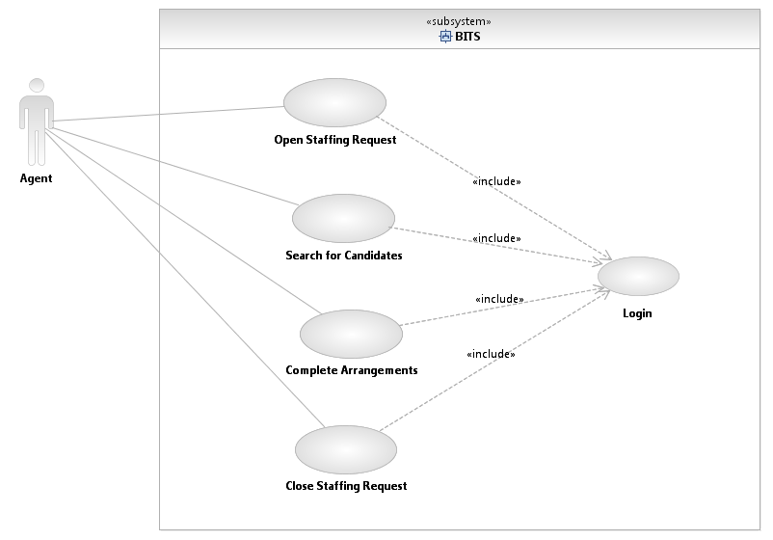

# Use Case Description

|  |  |  |
| --- | --- | --- |
| Use Case Name: **Complete Arrangements** | ID: **1.3** | Importance Level: **High Level** |
| Primary Actor: **Arrangement Specialist** | Use Case Type: **Detail, essential** | |
| Stakeholders and Interests:  **Arrangement Specialist — wants to contact candidate to see if position will be accepted.** | | |
| Brief Description: **An arrangement specialist from arrangements department wants to contact candidates to find out if position is accepted or rejected. Agent must first login to staff placement system in order to process candidate information.** | | |
| Trigger: **Arrangement Specialist**  Type: **External** | | |
| Relationships:  Association: **Arrangement Specialist**  Include: **Login**  Extend: None  Generalization: None | | |
| Normal Flow of Events:   1. Arrangement specialist executes the Login use case. 2. Arrangement specialist contacts candidate. 3. If candidate accepts Perform S-1 Candidate Accepts. 4. If candidate rejects Perform S-2 Candidate Rejects.   3. Arrangement specialist notifies staffing agent. | | |
| SubFlows:  **S-1** Candidate Accepts   1. Arrangement specialist marks candidate as placed 2. Arrangement specialist changes staffing request to filled 3. Arrangement specialist deletes staffing request in qualified list 4. Arrangement specialist creates bill of invoice   **S-2** Candidate Rejects   1. Arrangement specialist marks offer as rejected in staffing request qualified list 2. Arrangement specialist unreserves candidate 3. Arrangement specialist changes staffing request status to opened | | |
| Alternate/Exceptional Flows: | | |